Project 2

Program 1:

1. The program will have three integers as inputs by the user, and will output the smallest number of the three that is greater than 0
2. The code begins by outputting a greeting to the user to input the three integers. Then begins the branching to find the smallest. The code compares the first two numbers to zero, and then compares them too each other. Depending on which one is smaller, it will branch to a procedure, that compares that number to the third and final number and based on that, outputs which number is the smallest.
3. Leaf-procedures, User-input, Conditionals, Shutdown program, Jumping procedures
4. 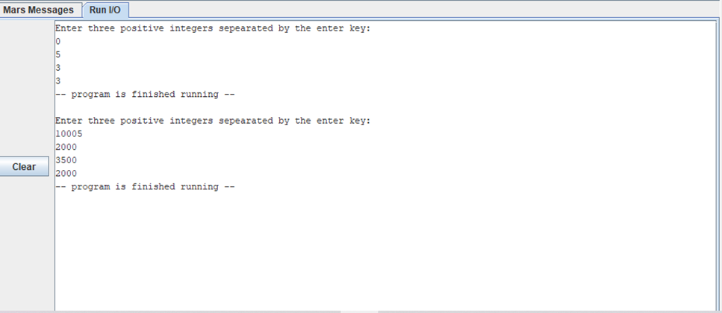

Program 2:

1. The program will ask for 2 different single-floating point inputs from the user. The program will output the calculated BMI for those numbers.
2. The code begins by asking the user to input 2 single-precision floating point numbers. The program then finds the inches from the feet provided by multiplying that by 12. Then it calculates total BMI by squaring the inches, then dividing the weight by that. At the end you multiply it all by 703 to find the BMI. Then the program uses branching procedures to determine if that BMI is underweight, normal, or overweight.
3. 
4. Leaf-Procedures, Floating point input, Floating point arithmetic, Floating point output, Floating point branching
5. Graphical user interface, text, application, email

   Description automatically generated

Program 3:

1. The program has 4 integers as input and outputs one integer representing total time
2. The program will ask the user to input 4 integers, representing number of hws and exercises and the avg time to do either. The program then passes those integers into a non-leaf procedure, where it calculate the total time by multiplying then adding the integers.
3. 
4. Non-leaf procedure, User input, Allocate space on stack, Deallocate space on stack, Passing registers into procedure
5. Graphical user interface, text, application, email

   Description automatically generated